ANNEX I: Deliverable Assessment Grid
Deliverable (Evaluation Grid) |  |  | D7.3 |  |  |  |  | Date |  |  |  | 30/06/2020
WP | 7.3 |  |  |  |  |  |  | Task Leader |  |  |  | FIAB
Author(s) |  | FIAB,All
Quality assurance Reviewer |  |  |  | Daniël van Straten |  |  |  |  | Partner | Aeres
The Deliverable comply with the description stated in the application form |  |  |  |  |  |  |  | Comments/Remarks
☐   |  |  | ☐   |  |  | ☐   | ☐   |  |  |  | x  
The Deliverable comply with all Task requirements |  |  |  |  |  |  |  | Comments/Remarks
☐ |  |  | ☐ |  |  | ☐ | ☐ |  |  |  | x
The information addressed the key issues |  |  |  |  |  |  |  | Comments/Remarks
☐ |  |  | ☐ |  |  | ☐ | ☐ |  |  |  | x
The information provided in the Deliverable are reliable |  |  |  |  |  |  |  | Comments/Remarks
☐ |  |  | ☐ |  |  | ☐ | ☐ |  |  |  | x
The Deliverable presented is using the project’s format |  |  |  |  |  |  |  | Comments/Remarks
☐ |  |  | ☐ |  |  | ☐ | ☐ |  |  |  | x
The Deliverable is written in good English |  |  |  |  |  |  |  | Comments/Remarks
☐ |  |  | ☐ |  |  | ☐ | ☐ |  |  |  | x
The Deliverable has been released by its due date |  |  |  |  |  |  |  | Comments/Remarks
☐ |  |  | ☐ |  |  | ☐ | x |  |  |  | ☐
Overall assessment |  |  |  | Suggestions for improvements:
☐ |  |  | ☐ |  |  | ☐ | ☐ |  |  |  | x
Date of Quality Assurance review |  |  |  |  | 30/07/2020
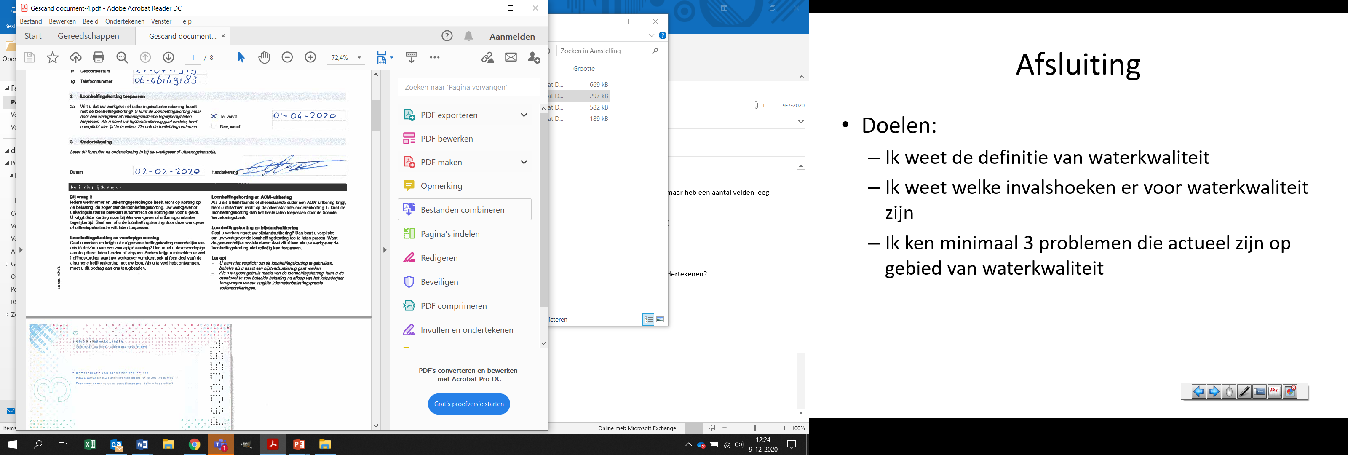
Signature:

In case of NOT ENOUGH & POOR grades the reporting of comments/remarks is mandatory, otherwise the assessment will be invalidated. Reviewer comments must be accurate, comprehensive and fully articulated.
In case of Technological Output, the Reviewer shall consider if the Deliverable description is comprehensive and coherent with the Technological Output.

