
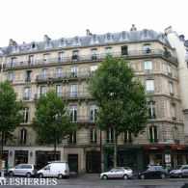

Access map ANIA – 9 bd Malesherbes – 75008 Paris

- ANIA
9 bd Malesherbes – 75008 PARIS
Push the P button to enter the building.
Then Door A (on the left side under the porch) code A9361B
Then 2nd floor – juste ring at ANIA - Tél : +33.6.17.36.45.61 (Françoise Gorga’s mobile)

- Metro - Madeleine 258 m
- Saint-Augustin 400 m

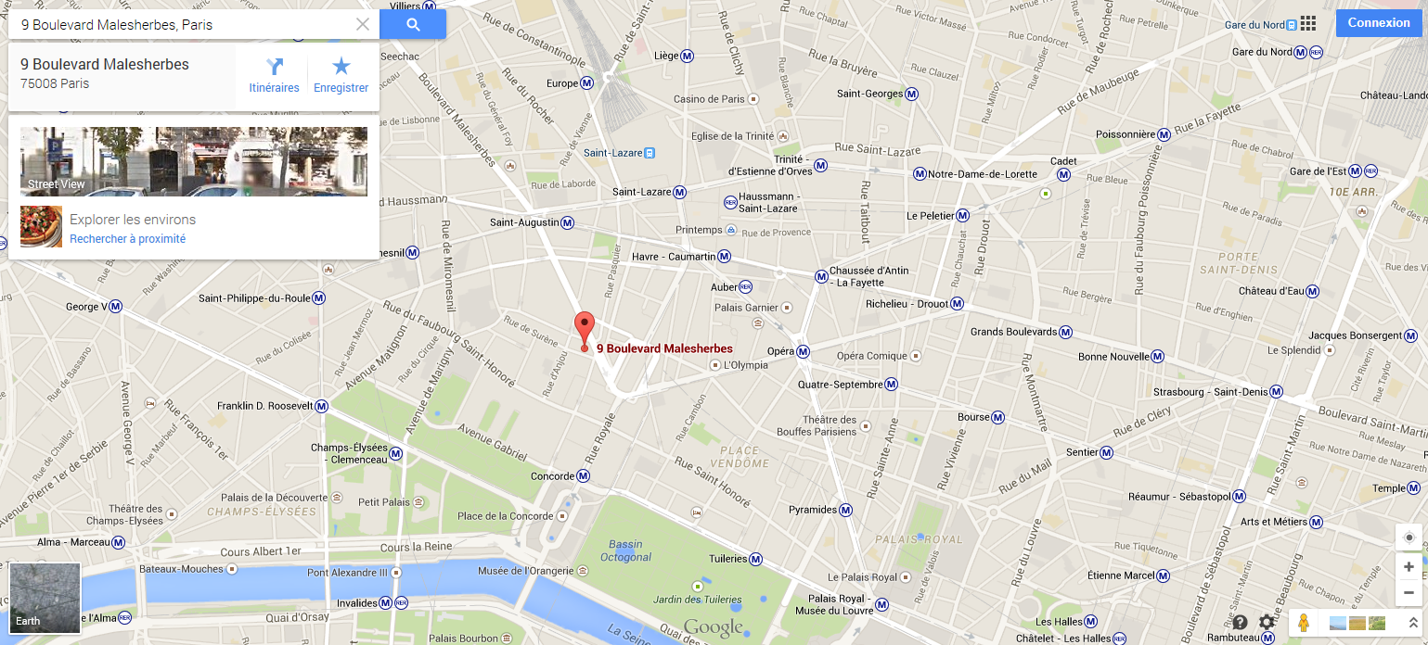

- How to get to ANIA’s office :
- From Charles de Gaulle airport : RER B to Gare du Nord / then RER E to Haussmann St Lazare et descendre au terminus / then 10 minutes walk
50€ for a Taxi (fixed rate)

- From ORLY airport : ORLYVAL to Antony / then RER B to Châtelet-les-Halles then metro Line 14 to Saint Lazare / stop at Madeleine.
35€ for a Taxi (fixed rate)

- hotels close to ANIA premises :
Hotels names (distance from ANIA’s office) |  / 
Hôtel La Sanguine (51m) (105/130 euros + breakfast 10 euros)  www.hotel-la-sanguine.com  6, rue de Surène  75008 Paris | +331 42 65 71 61
Hôtel Beau Manoir**** (63m)  6, rue Arcade 75008 PARIS  (from 120 euros) | +331 53 43 28 28
Hôtel Massena (800m)  16, rue Tronchet  75008 Paris | +331 47 42 71 22
Hôtel de l’ARCADE (108 m)  www.hotel-arcade.com  (from 135 euros)  9, rue de l’Arcade  75008 Paris | +331 53 30 60 00
Hôtel Caumartin Opéra (900m)  (165 euros)  27 rue de Caumartin  75009 Paris | +331 47 42 95 95
Hôtel ASTRA OPERA (415 m)  (180 euros)  29 rue de Caumartin  75009 Paris | +331 42 66 15 15
Hôtel Madeleine/ Haussmann*** (111m)  (from 185 euros)  10 rue Pasquier 75008 PARIS | +331 42 65 90 11

